# CS 255 System Design Document

## UML Diagrams

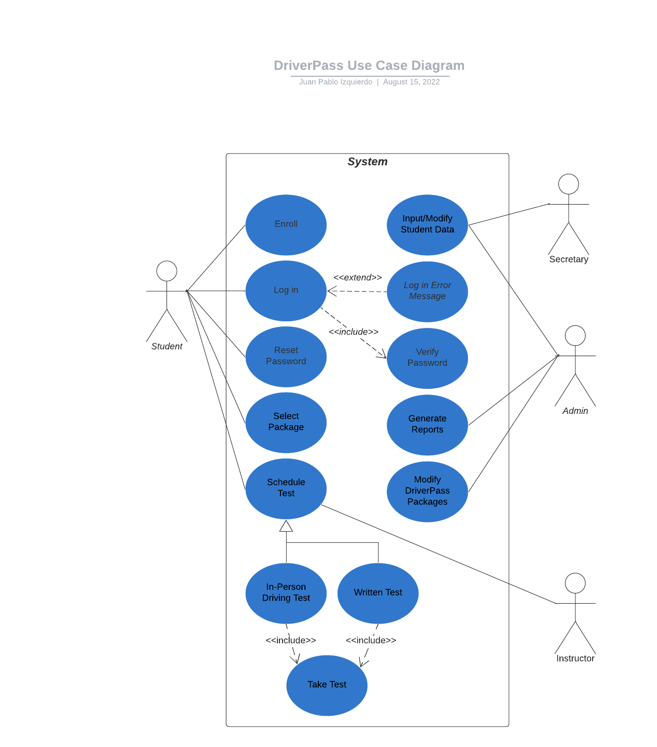

### UML Use Case Diagram

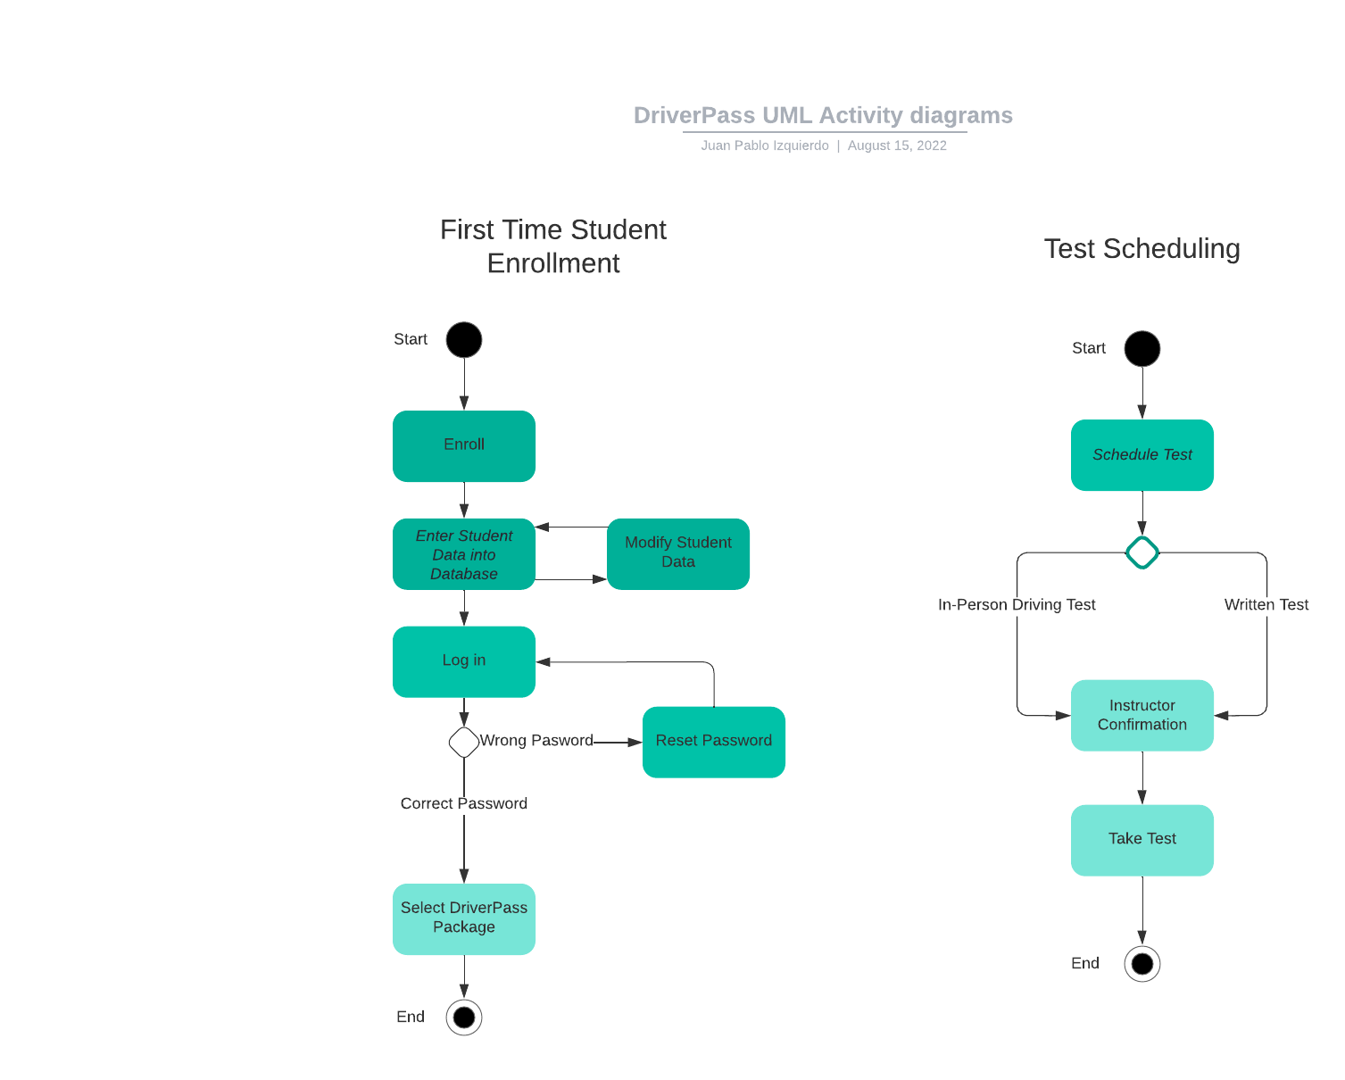

### UML Activity Diagrams

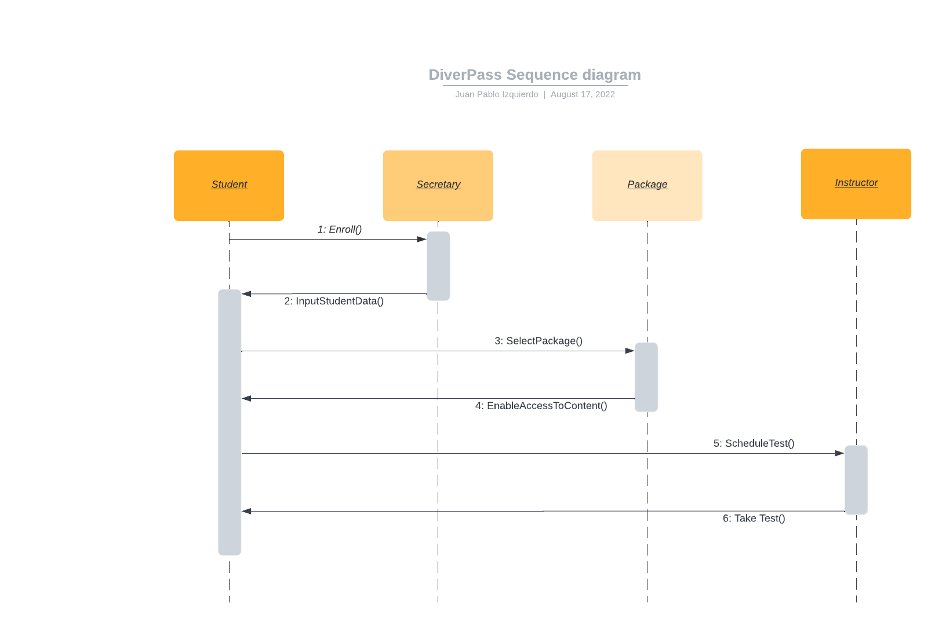

### UML Sequence Diagram

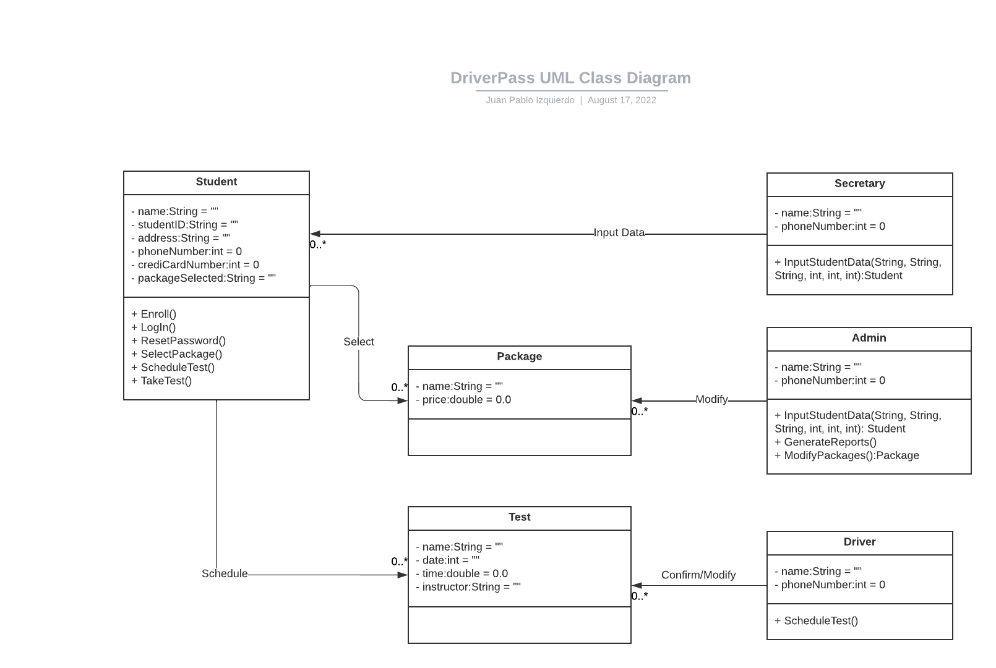

### UML Class Diagram

## Technical Requirements

Online capabilities of DriverPass will be more affordable and flexible if they are implemented on a cloud computing and storage system. The ability to grow and make changes quickly without having to worry about modifying and maintaining server hardware will be very important for the small DriverPass team, especially during the start-up phase of the company.

DriverPass can also use cloud storage and backup for admin, secretary, instructor, and most importantly, student personal and financial information. The security cloud services provide will increase DriverPass’ focus on the development of the application, directing most effort to getting the application up and running.

The DriverPass application will require a third party to received and handle payments, therefore, integration of a trusted online payment service will be fundamental for DriverPass’ success.

DriverPass’ library of study material must also be kept up to date with DMV regulations. Unfortunately, the automatic integration and update of course material is beyond the scope of this project, but we can add a notification system that reminds administrators and enables them to update the course material manually.

Several versions must also be created to accommodate different operating systems and mobile phone users. This is a critical selling point for DriverPass since they are facilitating access to online education and users must be able to access their study material from a diverse set of platforms.